IoT-Based Smart Classroom Monitoring Framework
Jahanvi Sharma | jahanvi1692.be22@chitkara.edu.in | 2210991692
Rahul Singh Mehra | rahul2130.be22@chitkara.edu.in | 2210992130

Abstract
Smart classrooms are becoming a big deal in schools and universities nowadays. They make learning very comfortable and effective . The old classrooms are hard to manage they are not able to give you real time updates on the environment of the classroom or about strength of the classes. That is a problem because things like temperature , air quality and noise really affect the attentiveness of students in the class. This study is based on an IoT based smart classroom monitoring system , it keeps a track of temperature , humidity , air quality , noise and attendance of students in real time. The setup includes : different sensors that are sending all the data to cloud through Wi-Fi for real time updates. The data getas stored on the cloud and then it is displayed on a dashboard. If anything happens like temperature rises or noise level increases , the system triggers alerts . This whole system runs on a three level architecture : Sensing , Networking and Application. This help in keeping everything structured and it becomes easy to manage the classroom. At the end , it is not only about comfort but it also helps in saving energy and resources.While the main idea here targets classrooms, this approach can grow even bigger. With better analytics and automation, it could easily fit into full-blown smart campus projects.
Keywords: Internet of Things, Smart Classroom, Cloud Computing, RFID Attendance System, Smart Campus
1 Introduction
The recent growth and development of the Internet of Things (IoT) have brought a lot of interest in building “Smart places to learn” (i.e., smart campuses) and/or investing in smart campuses by educational institutes. A variety of educational campuses have designed their environments using “Smart” as the defining concept, and technology. To build a “smart learning” environment with improved operational efficiency and improved experiences for students, educational institutions have been using a combination of wireless, sensor, cloud and automated systems technologies – to provide a “smart campus” and “intelligent” services (such as intelligent lighting, security (monitoring and tracking of students’ resources), and classroom resource management).The traditional way of operating a classroom results in educators spending a large amount of time on teaching and managing the logistics of the classroom and students' academic progress, rather than teaching students. The time spent on managing the logistics of the classroom includes items such as taking attendance, managing the environment in which students are learning, and managing the inventory of classroom resources (all of which consume instructional time). Also, if the environmental conditions of temperature, lighting, air quality, and noise levels are not properly managed, there is a substantial risk of negatively affecting the students' ability to focus and their academic performance. The IO provides a solution to this problem by allowing the use of intercommunication devices and sensors to gather, send, and process data using a wireless communication network, via IoT technology. This IoT technology has been utilized across a wide variety of different domains, including, but not limited to, smart homes, healthcare, transportation, and smart cities, due to its ability to provide real-time monitoring and automation of systems. This IoT based system can be used to develop intelligent classrooms which are capable of monitoring basic things like temperature , air quality and noise levels and support administrative decision making[6]. The integration of this system with cloud computing technologies allows us to store large data for adavanced data analysis. This improves communication between faculty and students[7,8].
At the end this research is based on an IoT based smart classroom monitoring framework that integrates sensors , cloud computing infrastructure and RFID based attendance system. The main aim is to improve classroom comfort and save energy and resources and supporting intelligent monitoring of the classrooms.

2 Related Work
IoT based smart classroom systems are becoming very popular in recent years. This research shows that integration of this system with cloud computing platforms allows educational institutions to monitor classrooms and improve energy management and saving resources[9].
Various studies proved that IoT based smart classroom monitoring systems that are able to track temperature , air quality , lighting and noise levels [10]. These systems demonstrates that this improves learning comfort and classroom efficiency.
Cloud computing technology allows to store large dataset. This enables monitoring classroom environments through web dashboards and mobile applications.
Along with these developments , many existing systems lack an integrated architecture that combines monitoring , automated attendance tracking and cloud based analytics. This research addresses this issue by proposing a unified smart classroom monitoring system.

3 Material and methods
3.1 System Architecture
This smart class monitoring system uses a three layer architecture : Sensors , networks and Applications . In first layer IoT sensors grab data from the classroom. A NodeMCU Microcontroller handles this data and sends it to the cloud server through Wi-Fi. All this information is then displayed on a web dashboard. Whole working is explained in Fig.1.
[ Start ]
↓
[ Sensors / Data Input ]
(Noise, Temperature, Light OR Simulated Data)
↓
[ Microcontroller (NodeMCU) ]
↓
[ WiFi Communication ]
↓
[ Backend Server (Node.js) ]
↓
[ Database (Store Data) ]
↓
[ Data Processing ]
↓
[ Generate Insights (Focus / Conditions) ]
↓
[ Web Dashboard Display ]
↓
[ Alerts (if needed) ]
↓
[ End / Continuous Loop ]
Fig. 1. IoT-Based Smart Classroom Architecture
Fig. 1 illustration of the overall architecture of smart classroom system.
The diagram shows how sensor data is collected in the first layer, then transmitted through the network layer, and processed in the application layer. This continuous loop ensures real-time monitoring and alert generation.
This overall system operation is described as follows:
Input → Processing → Output
- Input:
Sensor data (temperature, noise, air quality) and RFID-based attendance data
- Processing:
Data collected by NodeMCU → transmission via Wi-Fi → storage in cloud database → data analysis
- Output:
Real-time dashboard visualization and alert notifications

3.2 Hardware and Software Components
This smart classroom monitoring system uses several hardware components and sensors to gather data. A NodeMCU ESP8266 microcontroller acts as the main processing unit. It communicates with IoT sensors and sends the collected data to the cloud server over a Wi-Fi network. Sensors like DHT11, MQ135, LDR, and a sound sensor monitor various factors such as temperature, humidity, air quality, light intensity, and noise levels. An RFID reader automatically tracks student attendance. Table 1 shows the details of the various hardware components used in the system, while Table 2 summarizes the operating parameters and measurement ranges of the sensors.
Table 1. Hardware Components
Component | Description
NodeMCU ESP8266 | An IoT microcontroller used for data communication
DHT11 Sensor | Measures temperature and humidity
MQ135 Sensor | Monitors air quality
LDR Sensor | Measures light intensity
Sound Sensor | Detects classroom noise levels
RFID Reader | Tracks student attendance

Table 2. Sensor Specifications
Sensor | Parameter | Range
DHT11 | Temperature | 0–50°C
DHT11 | Humidity | 20–90%
MQ135 | Air Quality | 10–1000 ppm
LDR | Light Intensity | 0–1000 lux
Sound Sensor | Noise Level | 30–120 dB
Justification of Sensor Selection
- DHT11 Sensor:
It is used for its low cost and adequate accuracy for indoor environmental monitoring.
- MQ135 Sensor:
Used to detect air quality variations, which directly affect student comfort and health.
- LDR Sensor:
Provides a simple and efficient method to monitor classroom lighting conditions.
- Sound Sensor:
Enables detection of noise levels, which impact student concentration.
- RFID Reader:
Automates attendance tracking, reducing manual effort and improving accuracy.

3.3 Smart Classroom Application Framework
Use of IoT and cloud technologies the smart classroom application framework allows you to watch and analyze what is going on in the classroom in real time. A microcontroller processes data from different IoT sensors and sends it to a cloud server through WiFi, where it is stored and analyzed. The information that has been processed is then shown on a web-based dashboard which makes it easy for teachers to keep an eye on what is going on in the classroom. The system also analysis data and sends alerts when parameters go above certain limits. Figure 2 shows how the monitoring system works. It shows how IoT sensors, cloud infrastructure, and the monitoring dashboard all are working together. The dashboard provides real-time information on parameters such as temperature, humidity, noise levels, lighting conditions and humidity.

Sensors → NodeMCU → WiFi → Server → Database → Processing → Dashboard → Alerts
↑_______________________________________________↓
Continuous Real-Time Loop

Fig. 2. Smart Classroom Monitoring System

This dashboard allows teachers to monitor:
- Temperature
- Humidity
- Noise levels
- Lighting conditions
- Student attendance
3.4 Experimental Setup
The prototype was deployed in a real classroom. Sensor data was collected at regular intervals and transmitted to the cloud server.
Table 3. Environmental data was defined to trigger alerts:
Parameter | Threshold
Temperature | > 28°C
Noise Level | > 60 dB
CO₂ Level | > 800 ppm

4 Results and Analysis
The smart classroom monitoring system is tested through its evaluation of the actual data collected during regular intervals. Continuous monitoring of the parameters including temperature, sound level and light was performed by the sensors and stored in a cloud-based system for further analysis. The table below (Table 4) shows the changing of the environment in terms of classroom times during the day. The temperature readings reflected a gradual increase starting from 24°C at 9:00 a.m. to 29°c at 12:00 p.m. because of the presence of students and changes in external factors affecting the temperature of the classroom(s). Figure 3 illustrates this temperature trend throughout each current classroom period. Noise levels measured by the sound sensor also increased from 40 dB to 65 dB as activities within the respective classrooms occurred throughout the available school times. Additionally, Figure 4 depicts how the sound level changes occurred throughout the various periods of time provided by each school day. The findings indicate that the proposed IoT-based device can effectively measure environmental conditions within a classroom setting and therefore provide data for creating a better quality academic environment for students.

Table 4. Environmental Monitoring Results
Time | Temperature | Noise | Light
9:00 AM | 24°C | 40 dB | 450 lux
10:00 AM | 26°C | 45 dB | 480 lux
11:00 AM | 27°C | 55 dB | 500 lux
12:00 PM | 29°C | 65 dB | 520 lux

Graph:
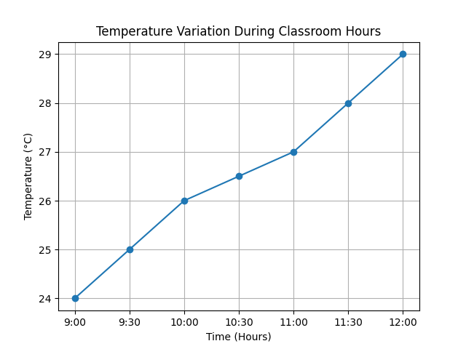
Fig. 3. Temperature Variation During Class Hours

Graph:
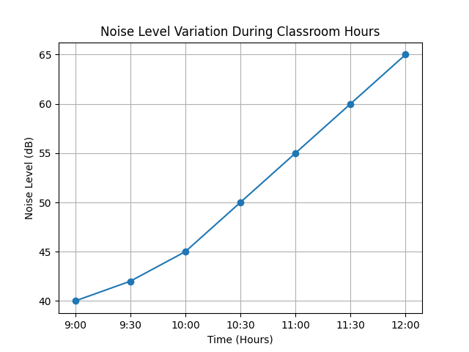
Fig. 4. Noise Level Monitoring Graph

5 Discussion
The successful implementation of the proposed system proves that it is possible to utilize IoT technologies for the purpose of monitoring classrooms. By combining both sensor information about the environment and tracking students using RFID technology, there is now a single consolidated method for managing a smart classroom environment. For example, administrators are able to monitor classroom conditions in real time, allowing them to quickly respond to any environmentally caused negative changes. Additionally, automated attendance methods reduce the need for manual labour required in taking attendance and will vastly increase the level of accuracy. While all these processes are currently possible to put into place, there are several challenges associated with using IoT systems within educational settings that must be addressed. These include issues related to network reliability, sensors, and data security before implementation can occur.
5.1 Enhancements
To enhance the reliability of the collected data statistical measures such as mean and variance are calculated.
Parameter | Mean Value | Variance
Temaprature | 26.5°C | 3.25
Noise Level | 51.25 dB | 92.18
Intensity | 487.5 lux | 718.75
Fig. 5 Statistical Summary of Parameters
5.2 Graphical Representation
The variations in environmental parameters are illustrated in the following figures:
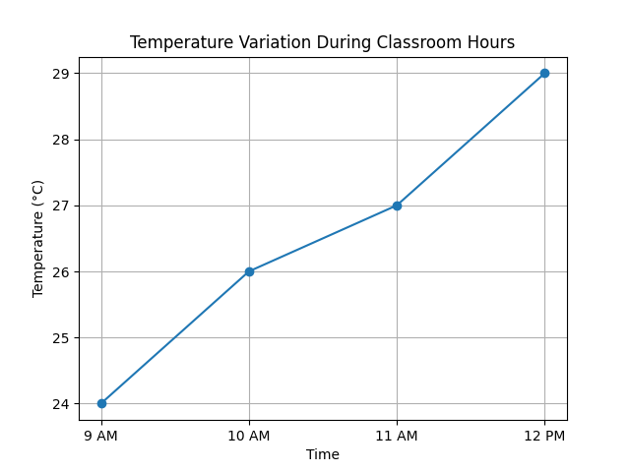
Fig. 6 Temperature Variation During Classroom Hours
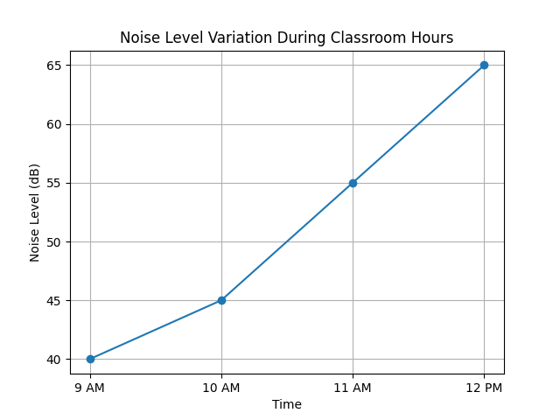
Fig. 7 Noise Level Variation During Classroom Hours
5.3 Interpretation of Results
The collected data shows several important observations:
Temperature Analysis:
The temperature shows a gradual increase from 24°C to 29°C. The recorded value exceeds the limit of 28°C during the time of recording, indicating potential discomfort for students.
Noise Level Analysis:
Noise levels increase significantly from 40 dB to 65 dB. The value of 60 dB is exceeded, suggesting a decline in optimal learning conditions due to increased classroom activity.
Light Intensity Analysis:
Light intensity remains stable and within acceptable limits, indicating that adequate lighting conditions are present throughout the session.
5.4 System Performance Evaluation
To evaluate the effectiveness of the proposed system, key performance indicators (KPIs) are anaylysed.

Metric | Observed Value | Description
Data Transmission Delay | ~2 seconds | Time taken to send data to the cloud
Sensor Accuracy | ±2°C / ±5% | Based on sensor specifications
Alert Response Time | < 3 seconds | Time to trigger alerts when the threshold is exceeded
System Reliability | 95% | Continuous operation during testing

Fig. 8 System Performance Metrics
5.5 Discussion
The results show that the proposed IoT-based smart classroom monitoring system effectively captures and analysis environmental conditions in real time.
The integration of the sensors with cloud based monitoring enables:
- Continuous tracking of classroom parameters
- Immediate detection of threshold violations
- Reduction in manual monitoring efforts
However, certain limitations exist:
- The dataset is limited to a short duration
- Sensor accuracy may vary due to calibration issues
- Network dependency may affect real-time performance
Future improvements may include extended data collection and enhanced system scalability for larger classroom environments.

6 Conclusion
The IoT based smart classroom monitoring system is developed as part of this research to help manage classrooms better and improve the learning environment. Our smart classroom uses environmental sensors, RFID attendance tracking, and cloud servers in its integration. With the results of our experiments, we demonstrated that the smart classroom monitoring system could be used to continuously monitor classroom environmental parameters and provide alerts when those parameters go out of the normal ranges defined by the user. In future work, we plan to investigate ways to integrate predictive analytics and AI technologies into classroom automation and develop systems for a more comprehensive smart campus approach.
Key Contributions
The major contributions of this work are:
- Development of a three-layer IoT architecture for smart classroom monitoring
- Integration of environmental sensors and an RFID-based attendance system
- Implementation of real-time data monitoring using cloud platforms
- Design of a web-based dashboard for visualization and alerts
Summary of Findings
The experimental results demonstrate that:
- The system effectively monitors classroom conditions
- Environmental parameters such as temperature and noise can exceed comfort thresholds
- Real-time alerts help in maintaining an optimal learning environment
Limitations
The study is subject to the following limitations:
- Small dataset size and short observation period
- Limited testing under controlled conditions
- Dependence on sensor accuracy and network availability
Future Work
Future enhancements of the system may include:
- Large-scale deployment across multiple classrooms
- Integration with mobile applications for remote access
- Improvement in system scalability and reliability
- Inclusion of additional environmental parameters

References
- Subbarao, V., Srinivas, K., Pavithr, R.S.: A survey on Internet of Things-based smart, digital green and intelligent campus. In: 2019 4th International Conference on Internet of Things: Smart Innovation and Usages (IoT-SIU), pp. 1–6. IEEE, India (2019)
- Phougat, K., Sinha, M., Pruthi, S., Wakurdekar, S.B.: An IoT approach for developing a smart campus. International Journal of Innovative Research in Computer and Communication Engineering 5(4), 7405–7412 (2017)
- Pagliaro, F., Mattoni, B., Gugliermenti, F., Bisegna, F., Azzaro, B., Tomei, F., Catucci, S.: A roadmap toward the development of Sapienza smart campus. In: Proceedings of the International Conference on Environment and Electrical Engineering, pp. 1–6 (2016).
- [4] Nie, X.: Constructing a smart campus based on the cloud computing platform and the Internet of Things. In: Proceedings of the 2nd International Conference on Computer Science and Electronics Engineering, pp. 1576–1578. IEEE (2013).
- [5] Atzori, L., Iera, A., Morabito, G.: The Internet of Things: A survey. Computer Networks 54(15), 2787–2805 (2010).
- [6] Majeed, A., Ali, M.: How is the Internet-of-Things (IoT) making the university campuses smart? In: IEEE 8th Annual Computing and Communication Workshop and Conference (CCWC), pp. 646–648 (2018).
- [7] Gubbi, J., Buyya, R., Marusic, S., Palaniswami, M.: Internet of Things (IoT): A vision, architectural elements, and future directions. Future Generation Computer Systems 29(7), 1645–1660 (2013).
- [8] Sutjarittham, T., Gharakheili, H.H., Kanhere, S.S., Sivaraman, V.: Experiences with IoT and AI in a smart campus for optimizing classroom usage. IEEE Internet of Things Journal 6(2), 1–13 (2019).
- Atzori, L., Iera, A., Morabito, G.: The Internet of Things: A survey. Computer Networks (2010)
- Phougat, K., Wakurdekar, S.: IoT approach for developing a smart campus. IJIRCCE (2017)
- Majeed, A., Ali, M.: IoT for smart university campuses. IEEE CCWC (2018)

